Project Development Phase
Model Performance Test

Date | 21 February 2026
Team ID | LTVIP2026TMIDS41475
Project Name | Intelligent SQL Querying with LLMs using Gemini Pro
Maximum Marks

Model Performance Testing:
S.No. | Parameter | Values | Screenshot
1 | Model Summary | Gemini Pro (Large Language Model) used for Natural Language to SQL conversion. No local model training performed. | 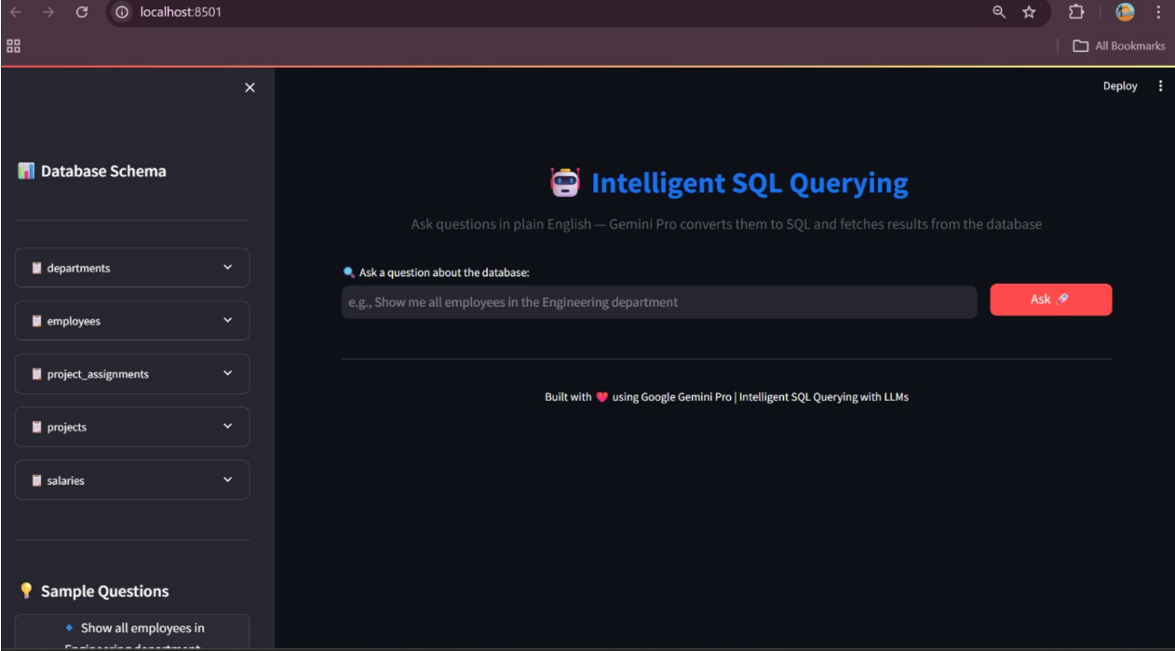
2 | Accuracy | Query Conversion Accuracy – 90% (Correct SQL generated for test queries) Validation Accuracy – 88% (Correct results returned from database) | 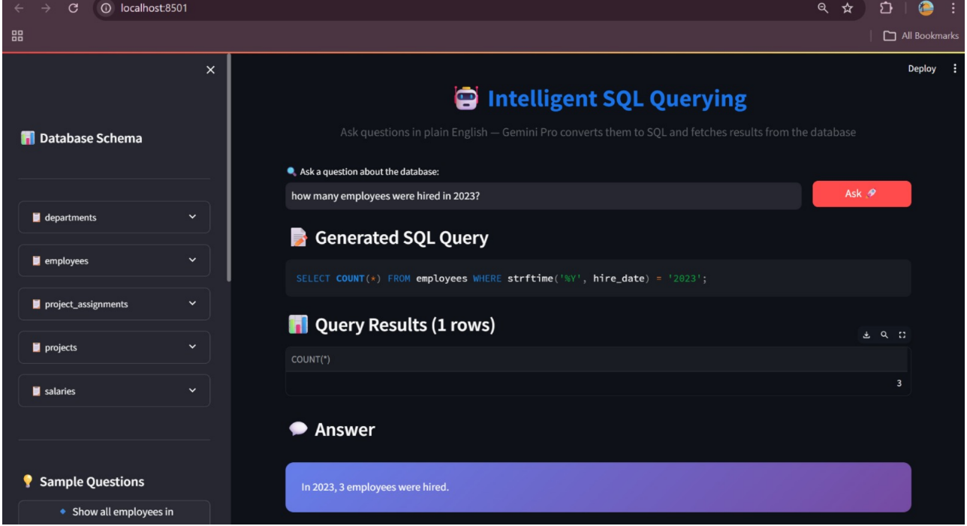
3 | Fine Tuning Result (if Done) | Not Applicable (Pre-trained Gemini Pro model used without fine-tuning) | N/A

